Attachment H – Sampling Toolkit

H.i: Recalled Water Cooler List

USEPA’s Water Cooler Recall List
Tables from EPA’s 3Ts for Reducing Lead in Drinking Water in Schools Revised Technical Guidance
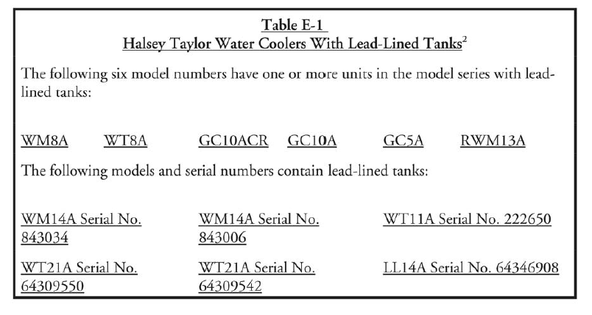
2Based upon an analysis of 22 water coolers at a US Navy facility and subsequent data obtained by EPA, EPA believes the most serious cooler contamination problems are associated with water coolers that have lead-lined tanks.

Per EPA’s 3Ts for Reducing Lead in Drinking Water in Schools Revised Technical Guidance, a company formerly associated with Halsey Taylor, Scotsman Ice Systems, has assumed responsibility for replacement of lead-line coolers previously marketed by Halsey Taylor. See below for the address of Scotsman Ice Systems.

Scotsman Ice Systems
775 Corporate Woods Parkway
Vernon Hills, IL 60061
PH: (800) SCOTSMAN or 800-726-8762
PH: (847) 215-4500

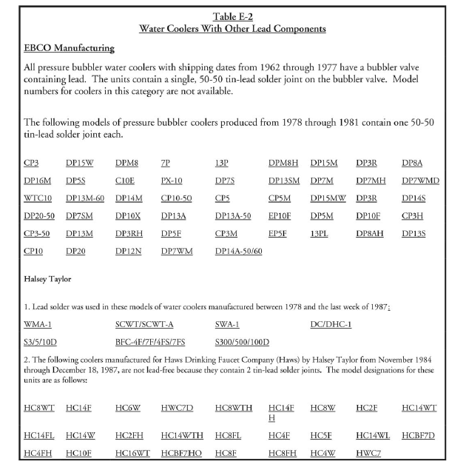

United States Environmental Protection Agency 3Ts for Reducing Lead in Drinking Water in Schools

